Activated anti-tumor immune infiltrates are associated with improved survival in p53 abnormal endometrial carcinoma

Spencer D Martin1, Shelby Thornton2, Christine Chow2, Katy Milne3, Juliana Sobral de Barros1, Amy Jamieson4, Brad H Nelson3, Dawn R Cochrane1, David G Huntsman1, C Blake Gilks1, Lien Hoang1, Jessica N McAlpine4*, Allen W Zhang1*

Affiliations

1. Department of Pathology and Laboratory Medicine, Faculty of Medicine, University of British Columbia, Vancouver, Canada
2. Molecular and Advanced Pathology Core (MAPcore), University of British Columbia, Vancouver, Canada
3. Trev and Joyce Deeley Research Centre, British Columbia Cancer Agency, Victoria, Canada
4. Department of Obstetrics and Gynaecology, University of British Columbia, Vancouver, Canada

**Abstract**

TODO: abstract

## 1 Introduction

Endometrial cancer is the second most common type of gynecologic malignancy worldwide and the most common gynecologic malignancy in North America [(1)](https://www.zotero.org/google-docs/?DDOLq7). Molecular classification stratifies endometrial cancers into 4 prognostically distinct subtypes: polymerase epsilon-mutated (POLE), mismatch repair-deficient (MMRd), p53 abnormal (p53abn) and no specific molecular profile (NSMP) [(2–5)](https://www.zotero.org/google-docs/?1m8C1d). p53abn cancers are the worst prognostic subtype, comprising only 15% of all endometrial cancers but accounting for 50-70% of mortalities [(3,6–8)](https://www.zotero.org/google-docs/?IBFhPu), with extrauterine involvement in over 50% of cases [(5,9)](https://www.zotero.org/google-docs/?cJEwWm). Most p53abn tumors recur within five years on standard-of-care carboplatin-paclitaxel chemotherapy with or without adjuvant radiotherapy, highlighting the need for alternative therapeutic options [(6,7,10)](https://www.zotero.org/google-docs/?ykHNxk). While several studies have investigated associations between immune infiltration and survival in endometrial carcinomas [(11–14)](https://www.zotero.org/google-docs/?7guZR0), large scale studies investigating the immune composition of p53abn tumors are lacking.

The interplay between different immune cell types within the tumor microenvironment determines the effectiveness of anti-tumor immunity. CD8+ cytotoxic T lymphocytes (CTL) are the main cells that recognize and kill tumor cells. Dendritic cells, macrophages and B cells are professional antigen presenting cells that activate CTL and CD4+ helper T cells (TH), which in turn secrete cytokines that potentiate the activity of CTL and anti-tumor macrophages. CD68+ macrophages can either help activate CTL, by presenting antigens and co-stimulatory molecules, or inhibit CTL, by presenting antigens along with inhibitory ligands [(15,16)](https://www.zotero.org/google-docs/?cHYnph). CD3+FOXP3+ regulatory T cells (Tregs) inhibit anti-tumor immunity by secreting cytokines that block CTL maturation and activity and induce macrophages to express immune inhibiting molecules [(17,18)](https://www.zotero.org/google-docs/?Je2tWx). Finally, CD20+ B cells and CD79a+ plasma cells may potentiate anti-tumor immunity via multiple mechanisms [(19,20)](https://www.zotero.org/google-docs/?MS4ByO). Key functional molecules that inhibit anti-tumor immunity include indoleamine 2,3-dioxygenase 1 (IDO1) and programmed death-ligand 1 (PD-L1). Macrophages and tumor cells may express IDO1, which limits tryptophan availability, thereby inducing CTL death and proliferation of Tregs [(21)](https://www.zotero.org/google-docs/?fPNd0L). Tumors and macrophages may also express PD-L1, blocking CTL mediated killing when bound to programmed cell death-1 (PD-1) on CTL and TH [(22)](https://www.zotero.org/google-docs/?vXPJQQ). The cytokines released when CTL kill tumor cells cause upregulation of both IDO1 and PD-L1 [(22)](https://www.zotero.org/google-docs/?DE08Ga); thus, expression of PD-L1 has been used as a marker for an active anti-tumor immune response in multiple different cancer types [(23–25)](https://www.zotero.org/google-docs/?M8OLL7).

Immune checkpoint inhibitors disrupt the PD-1 – PD-L1 pathway, reactivating exhausted T cells to attack tumor cells. These treatments are particularly effective in tumors with elevated numbers of mutations that generate neoantigens [(26)](https://www.zotero.org/google-docs/?KN1qSX). In endometrial cancer, POLE and MMRd tumors have over 10 times as many mutations as p53abn and NSMP tumors [(2,13)](https://www.zotero.org/google-docs/?Ypa8AW) and correspondingly higher TIL densities [(14)](https://www.zotero.org/google-docs/?OcWckc). While systemic therapy is often unnecessary in POLE cancers due to exceptionally favorable outcomes with hysterectomy alone, anti-PD-1 immune-checkpoint inhibitors have demonstrated remarkable efficacy in advanced, recurrent and persistent MMRd endometrial cancers, even after multiple lines of therapy [(27,28)](https://www.zotero.org/google-docs/?8lq7lc). More recently, Mirza et al. [(29)](https://www.zotero.org/google-docs/?ZZEY0V) showed benefit of adding dostarlimab, a PD-1 inhibitor, to chemotherapy in both MMRd and in MMR-proficient (MMRp) endometrial carcinomas. Subgroup analysis showed that the benefit in MMRp was driven by p53abn cases [(30)](https://www.zotero.org/google-docs/?b4VJHC), and thus dostarlimab received FDA approval for treatment of endometrial carcinoma, regardless of subtype. However, the factors underlying response to immune checkpoint inhibitors in p53abn endometrial cancer remain poorly understood.

Additional classes of targeted therapies under investigation in p53abn endometrial cancer include PARP inhibitors and HER2-directed antibodies [(31)](https://www.zotero.org/google-docs/?zfofUO). PARP inhibitors have become standard-of-care in *BRCA1*/*BRCA2*-mutated or homologous recombination deficient (HRD) cancers in several cancer types [(32)](https://www.zotero.org/google-docs/?5dUanj). In high-grade serous ovarian cancer (HGSOC), HRD tumors have higher immunogenicity than non-HRD tumors, and markers of adaptive immunity are associated with longer overall survival in HRD but not non-HRD tumors [(33)](https://www.zotero.org/google-docs/?BPjZmb). In p53abn endometrial cancer, approximately 25% of cases show evidence of HRD and fewer than 5% have *BRCA1/2* mutations [(34,35)](https://www.zotero.org/google-docs/?rkuRVS), and the relative immunogenicity of these cases has yet to be explored. Several phase I and II clinical trials assessing HER2-targeted therapies are in progress [(36–38)](https://www.zotero.org/google-docs/?EBYqGc), but to date, studies investigating the relative immunogenicity of HER2-amplified p53abn endometrial carcinoma is lacking. Understanding the relationship between HRD, HER2 status and the immune microenvironment in p53abn endometrial cancers may help inform combination PARP inhibitor, HER2 blockade and immunotherapy in clinical trials [(39)](https://www.zotero.org/google-docs/?6xBTqr).

To understand the clinical relevance of the immune response to p53abn endometrial cancer, we systematically profiled the immune cell composition of 256 clinically annotated p53abn endometrial cancers with multiplex immunofluorescence for CTL, TH, Tregs, B cells, plasma cells and macrophages. Further, we evaluated the expression patterns of PD1, PD-L1 and IDO1, three pharmacologically actionable immunosuppressive molecules with translational relevance to current clinical trials in endometrial cancer. Finally, we investigated the relationship between immune composition, homologous recombination deficiency, and HER2 expression/amplification in p53abn endometrial cancer.

## 2 Methods

### 2.1 Data acquisition

#### 2.1.1 Sample acquisition and TMA construction

Ethics approval was obtained from the University of British Columbia (UBC) Research Ethics Board (approval number H18-01652) and the institutional review boards from each center that supplied tissue. The cohort consisted of 256 treatment-naive p53-abnormal endometrial carcinomas collected between 1993 and 2017 in Vancouver and in 10 tertiary and 19 community centers from across Canada. Clinicopathologic and outcome data were collected by chart review. All cancers were classified as p53abn according to the ProMisE algorithm [(3)](https://www.zotero.org/google-docs/?L5k8TS) by immunohistochemistry for p53 and MMR proteins and next-generation sequencing for POLE hotspot mutations. Representative samples of p53abn endometrial carcinomas were cored at 0.6 mm in diameter, in duplicate, and arrayed as described previously [(3)](https://www.zotero.org/google-docs/?urhz3m).

#### 2.2.2 Multiplex immunofluorescence

TMAs were cut at 4 mm for immunofluorescence. Two multiplex immunofluorescence panels were constructed consisting of the following antibodies (1) CD3, CD8, FOXP3, CD20, CD79a, panCK, and (2) PD1, PD-L1, IDO1, CD8, CD68, panCK. The following antibodies and staining procedures were used: _______________. For each immunofluorescence panel, optimal staining parameters were determined as single stains and validated in the multiplex. Once stained, TMAs were imaged using (###).

### 2.3 Computational analysis

#### 2.3.1 Cell and region counting

Analysis was performed using HALO (Version 3.6.4134.95). Briefly, three tissue segmentation and cell segmentation/phenotyping algorithms were trained using 10 – 30 representative images for each algorithm. Regions were classified as epithelial, stromal, glass, or other (including necrosis) for tissue segmentation. The mean and standard deviation of cell count and region area across all algorithms was calculated for each core and reviewed by a technologist. Any core with a standard deviation of >5 among the three algorithms, or with abnormal features as identified by the technologists, were flagged for review and manual annotation by a pathology resident and/or subspecialist gynecological pathologist. Sarcomatoid areas in carcinosarcomas were considered epithelial. Intraepithelial area that was negative for CD68 and CD8 was designated tumor cell area. All immune cells touching tumor cells were considered intraepithelial. TIL counts and areas for all duplicate cores from each sample were added together. TIL densities were computed by taking the quotient of TIL counts divided by areas (epithelial or stromal), and log-transformed TIL densities were computed as log(TIL density + 1).

#### 2.3.2 Mixture modeling of cell counts

The TIL count $y_{i,c,r}$ for a given core $i$, cell type $t$, and region (tumor/stroma) $r$ was described as follows:

$$y_{i,t,r}∼NB\left(μ_{i,t,r},α_{i,t,r}\right)$$

where the mean $μ_{i,t,r}$ follows:

$$μ_{i,t,r} =A_{i,r}z_{c_{i},t,r}$$

$$z_{c,t,r} ∼Gamma\left({μ‾}_{t,r},100\right)$$

where $c_{i}$ is the inferred cluster of core $i$, $A_{i,r}$ is the area of region $r$ in core $i$, and ${μ‾}_{t,r}$ is the mean density (count divided by area) value across all cores $i$. The Gamma distribution was parameterized in terms of a mean and scale parameter, with the scale parameter set to 100 to allow for a fairly uninformed prior.

To reduce the dimensionality of the parameter space, the dispersion parameter $α_{i,t,r}$ was formulated semi-parametrically in terms of a set of Gaussian radial-basis kernels with parameters $a_{k}$ and $b_{k}$, for a specified number of centers ${y‾}_{k}$ uniformly distributed between 0 and the maximum number of counts [(40,41)](https://www.zotero.org/google-docs/?6QGyZv), with the default number of centers set equal to 20:

$$α_{i,t,r} =\sum_{k}{}a_{k}exp\left(-b_{k}{\left(z_{c_{i},t,r}-{y‾}_{k}\right)}^{2}\right)$$

$$a_{k} ∼Lognormal\left(0,1\right)$$

$$b_{k} ∼Lognormal\left(0,1\right)$$

where $a_{k}$ and $b_{k}$ follow relatively agnostic lognormal priors as above.

Inference was performed in pymc v5.9.1 [(42)](https://www.zotero.org/google-docs/?jaKnXH) with the number of tuning and sampling iterations set to 1000 each. Continuous parameters were sampled with the No-U-Turn Sampler (NUTS) and categorical parameters were sampled with the Metropolis sampler. Convergence was assessed by examining trace plots. To determine the optimal number of clusters $\left|C\right|$, a Dirichlet process prior was first fitted to a version of the model marginalized over cluster membership $z$. Two clusters with proportions of at least 0.05 (5%) were inferred (first cluster with mean proportion 0.588, 95% CI 0.512-0.656; second cluster with mean proportion 0.347, 95% CI 0.289-0.407). The lower bound of the 95% CI for the third most prevalent cluster was 0.004 (i.e. 1 out of the 256 input samples), supporting the presence of only 2 main clusters. Thus, the model was fitted again with the number of clusters fixed at 2 ($\left|C\right|=2$) to determine cluster membership $z$ for each input sample.

#### 2.3.3 Shallow whole-genome copy number analysis

Copy number (CN) signatures were generated as described in [(35)](https://www.zotero.org/google-docs/?DkR9bG) using the process outlined by [(43)](https://www.zotero.org/google-docs/?EChvKT), as implemented by the Utanos R package (<https://github.com/Huntsmanlab/utanos>). In short, CN features such as DNA segment size, CN change points, segment CN, breakpoints per 10Mb, length of segments with oscillating CN, and breakpoints per chromosome arm were extracted using the ExtractCopyNumberFeatures function in Utanos. The optimum number of signatures was determined by the ChooseNumberSignatures function, subsequently, the GenerateSignatures function was applied to the selected number of signatures. Finally, the CN signatures were generated according to the sample by signature exposures. Five CN signatures were identified in our p53abn cohort, one of them (VS5) associated with BRCA1/2 CN Loss. VS5 samples also had a higher exposure to the HRD CN signature (BS3) described by [(43)](https://www.zotero.org/google-docs/?sqTe2c) in HGSOC samples. HER2 (*ERBB2*) amplification was defined by an absolute copy number (ACN) greater than 4.5 copies. ACN was determined from relative copy number profiles using Rascal [(44)](https://www.zotero.org/google-docs/?SKFh9w). These results were corroborated by immunohistochemical staining for HER2 as described in [(14)](https://www.zotero.org/google-docs/?px5ZGc).

#### 2.3.4 Statistical analysis

All statistical analysis was performed in R (v4.3.2). The Mann-Whitney U test was used to evaluate significance in two-way comparisons. Comparisons for categorical count data were evaluated for significance with Fisher’s exact test. Multiple testing correction was performed with the Holm method. Results with adjusted *P* < 0.05 were considered statistically significant.

*P* values for Kaplan-Meier analyses were computed with log-rank tests. Cox proportional hazards analysis was performed with the survival package (v3.5-7) in R. Samples with missing values were excluded from analysis. Proportional hazards assumptions were evaluated with weighted Schoenfeld residuals [(45)](https://www.zotero.org/google-docs/?C2fdg1). Hazard ratios and *P* values from the survival package were validated for consistency with a Bayesian implementation of the Cox proportional hazards model.

Hierarchical clustering was performed with Euclidean pairwise distance and Ward’s method.

#### 2.3.5 Code availability

Code associated with this project is publicly available at <https://github.com/Irrationone/tfri_halo>.

## 3 Results

### 3.1 Cohort

We assembled a cohort of 256 treatment-naive p53abn endometrial carcinomas diagnosed between 1993 and 2017 (**Figure 1**) [(14)](https://www.zotero.org/google-docs/?6PhDiT). Histotypes of p53abn tumors included serous (n=136), endometrioid (n=52), carcinosarcoma (n=31), clear cell (n=15), mixed (n=17) and other (n=5). All patients received treatment in accordance with standard-of-care at the time of diagnosis, with most patients receiving adjuvant chemotherapy and a smaller proportion receiving adjuvant brachytherapy or radiotherapy (**Figure 1**). No patients received immunotherapy or neoadjuvant chemotherapy.

|  |
| --- |
| *Figure 1:* Graphical overview of clinicopathologic parameters and data types for each sample, showing the relationships between different parameters. Missing values in each row are colored white. |

### 3.2 Clustering based on immune composition

We performed multiplex immunofluorescence and automated image analysis to segment tumors into epithelial, stromal and other regions and quantified lymphocyte subsets, including CTL (CD3+CD8+), TH (CD3+CD8-FOXP3-), Treg (CD3+CD8-FOXP3+), B cells (CD20+CD79a+) and plasma cells (CD20-CD79a+) (**Figure 2a**). Cells within epithelial and stromal regions were counted separately, and automated counts were manually verified. We found that all TIL densities were highly correlated. Higher correlations between TIL types were seen within specific regions, and the highest correlations were seen within cell type subsets within regions (**Figure S1**).

|  |
| --- |
| *Figure S1*: Pairwise correlations between epithelial and stromal TIL subtype densities in p53abn endometrial carcinoma. Colors and numbers within the heatmap correspond to the Pearson correlation coefficient (*R*). All pairwise comparisons were statistically significant (adjusted *P* < 0.001). |

Next, we clustered tumors based on epithelial and stromal counts normalized by region area with a negative binomial mixture model. As the number of immunologically distinct clusters was unknown *a priori*, the model was formulated to automatically determine the optimal number of clusters using a Dirichlet process (**Methods**). Two distinct clusters were found: a TIL-rich and a TIL-poor cluster. T and B cell subsets, including CTL, TH, Treg, B cells, and plasma cells infiltrated both tumor stroma and epithelium in TIL-rich tumors (**Figure 2b**). We found no evidence of a subgroup with stroma-restricted TIL, contrary to our findings of an immunologically and genomically distinct subgroup of tumors with stroma-restricted TIL in high-grade serous ovarian carcinoma [(33)](https://www.zotero.org/google-docs/?YpjKIW).

### 3.3 TIL-rich tumors are associated with longer survival

We next assessed the relationships between TIL cluster, survival, and other clinicopathologic parameters in our cohort of p53abn endometrial carcinomas. In multivariate Cox proportional-hazards analysis, significant associations were identified between overall survival and adjuvant chemotherapy (HR 0.58, *P* = 0.041) and FIGO stage (HR 3.39 and 11.0 for stage III and IV compared to stage I, respectively, both *P* < 0.001), while older age trended towards shorter overall survival (HR 1.02, *P* = 0.14). Importantly, TIL-rich tumors significantly associated with prolonged overall (HR 0.63, *P* = 0.031) and disease-specific survival (HR 0.58, *P* = 0.037) in multivariate Cox proportional-hazards analysis accounting for age at diagnosis, FIGO stage [(46)](https://www.zotero.org/google-docs/?Bb4dEA), and adjuvant treatment (**Table 1**), and trended towards longer progression-free survival (HR 0.74, *P* = 0.15). No single TIL type was associated with survival when considered individually (sup fig). Surprisingly, univariate Kaplan-Meier analyses failed to identify a significant association between TIL-rich cases and overall, progression-free, or disease-specific survival (all *P >* 0.175) (**Figure 3a**).

To better understand the discordance in the effect of TIL between univariate and multivariate analyses, we assessed the TIL effect stratified by stage and adjuvant therapy. Univariate Kaplan-Meier analysis stratified by stage highlighted that the association between TIL cluster and survival was most pronounced in patients with stage III disease (**Figure 3b-e**). The median 5-year overall survival in stage III disease for TIL-poor cancers was 24.9% (95% CI, 9.6%-64.7%) versus 55.2% (95% CI, 38.3%-79.6%) for TIL-rich stage III cancers (n = 71). In contrast, the median 5-year overall survival in stage I disease for TIL-poor cancers was 74.9% (95% CI, 61.9%-90.6%) versus 79.1% (95% CI, 67%-93.4%) for TIL-rich stage I cancers (n = 118). Interpretability within stage II and IV tumors was limited by smaller sample sizes (**Figure 3c,e**). Thus, TILs were associated with longer survival in p53abn endometrial carcinoma, particularly in advanced stage disease. When we stratified the cohort based on adjuvant chemotherapy use, we found that despite higher rates of chemotherapy use in stage III and IV disease in our cohort (*P* < 0.001), TIL-rich cases were associated with significantly longer disease-specific survival (*P* = 0.03) and trended towards longer progression-free survival and overall survival (*P* = 0.067 and 0.09, respectively) only in patients who did not receive chemotherapy. (**Figure 3f,g**). This finding was only significant when all stages were assessed as there were only trends within each stage due to lack of power, and the association was independent of chemotherapy use.

### 3.4 Association between TIL cluster and histologic subtypes of p53abn endometrial carcinoma

p53abn endometrial carcinomas comprise a mixture of serous and other histotypes including carcinosarcoma, endometrioid and clear cell. Histotype was significantly associated with TIL cluster (*P* = 6.51e-03), with carcinosarcomas the most TIL-poor histotype and serous carcinomas the most TIL-rich (**Figure 4**). 74% (23/31) of carcinosarcomas were TIL-poor, compared to only 43% 97/224 of non-carcinosarcoma histotypes (adjusted *P* = 0.011) (**Figure 2b**). Apart from carcinosarcomas, there were no significant pairwise differences in TIL cluster distribution between any of the other non-serous histotypes and serous carcinomas (the most common histotype). In multivariate survival analysis accounting for carcinosarcoma histotype and TIL cluster, carcinosarcomas trended towards shorter overall, progression-free and disease-specific survival, consistent with prior findings [(47–49)](https://www.zotero.org/google-docs/?1oJOjr), but this was not statistically significant (all *P* > 0.067). The association between the TIL-rich cluster and overall survival remained significant when accounting for the carcinosarcoma histotype (HR 0.65, 95% CI 0.426-0.989, *P* = 0.044), suggesting that TIL cluster is prognostic independently of histotype.

|  |
| --- |
| *Figure 2: Derivation of TIL-rich and TIL-poor groups.* (a) Representative multiplex immunofluorescence image of the B/T cell panel. Representative segmentation of the tumor (red), stromal (green), and glass/necrosis (blue) are shown in the top left panel. Cytokeratin (white) and DAPI (blue) are shown in each image along with a single immune marker as annotated. (b) Heatmap of log-transformed epithelial and stromal TIL densities for each sample. Results of hierarchical clustering by sample (top dendrogram) are split by TIL cluster. |

|  |  |
| --- | --- |
| |  | | --- | |  |   *Table 2:* Hazard ratios, 95% confidence intervals, and significance values for TIL cluster and each clinicopathologic variable included in multivariate survival analysis (overall survival, progression-free survival and disease-specific survival). |

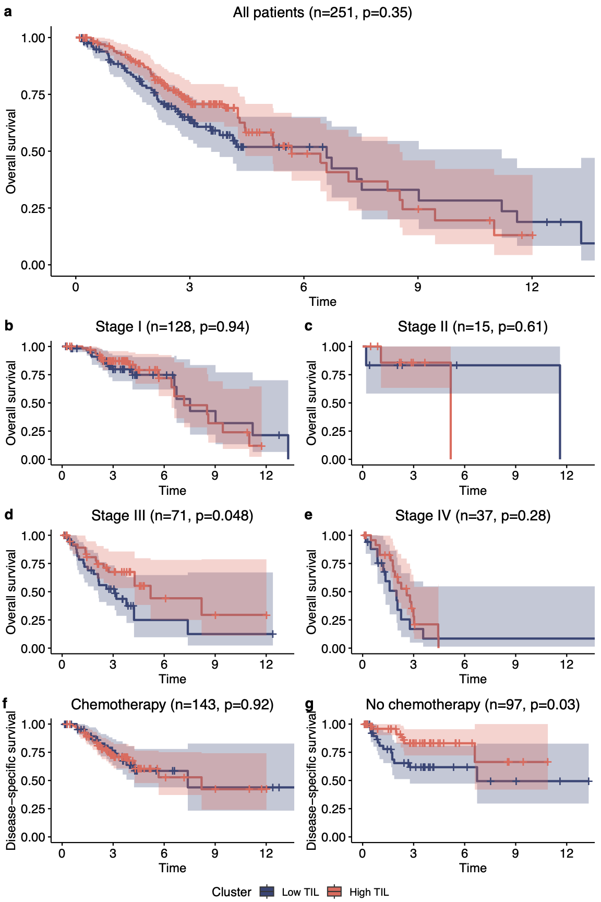

|  |
| --- |
| *Figure 3*: Univariate Kaplan-Meier survival curves and log-rank *P* values of overall survival and TIL cluster, for (a) all tumors in the cohort with known stage and chemotherapy status; (b)-(e) tumors broken down by stage. Univariate Kaplan-Meier survival curves and log-rank *P* values of disease-specific survival and TIL cluster (f-g) broken down by adjuvant chemotherapy status. |

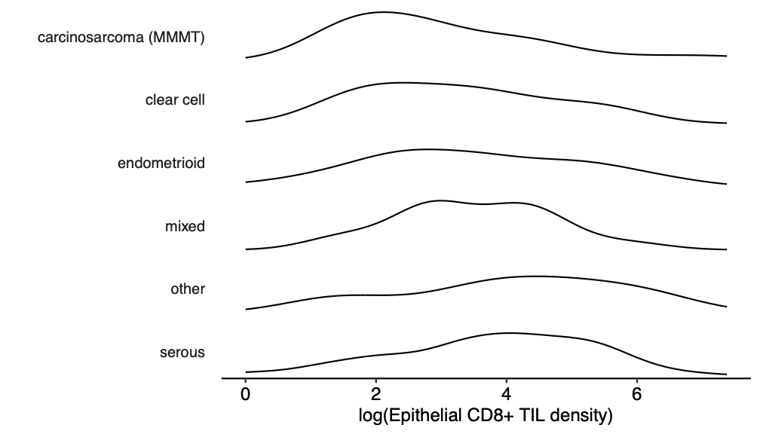

*Figure 4*: Distribution of epithelial CD8+ TIL densities for each histotype.

### 3.5 Immune composition and activity is altered in TIL-rich samples

To further explore anti-tumor immunity and the tumor response to immunity, we assessed CD8+ T cell activation, immune subset composition, and macrophage and tumor expression of immune inhibiting molecules (Sup figure ##). Consistent with our previous findings [(14)](https://www.zotero.org/google-docs/?T8YarR), TIL-rich tumors contained more of both CD8+PD1+ (activated CTL) and CD8+PD1- (naïve T cells), as expected since CD8+ T cells helped derive the TIL-rich group (**Figure S2**). However, activated CTL made up a greater percentage of total CD8 T cells (**Figure 5a**). Furthermore, the CTL to Treg ratio (CTL:Treg) was significantly elevated within epithelium but not stroma of TIL-rich tumors, suggestive of increased anti-tumor intra-epithelial CTL activity (**Figure 5b**).

Tumor cells and macrophages upregulate PD-L1 and IDO1 in response to CTL and TH expressed cytokines, thereby inhibiting anti-tumor immune attack [(50)](https://www.zotero.org/google-docs/?MgeDiN). While there was no significant difference in the density of PD-L1-negative macrophages between TIL-rich and TIL-poor tumors in our cohort, we found PD-L1-positive and PD-L1+IDO1+ macrophages were significantly enriched in TIL-rich tumors (both *P* < 0.001) (**Figure 5c**). Furthermore, PD-L1+ and IDO1+ tumor cells were significantly enriched in TIL-rich tumors (all *P* < 0.001) (**Figure 5d**). Together, these results demonstrate that TIL-rich tumors were not only enriched for immune cells, but also that the immune cells actively participated in anti-tumor immunity that the tumor attempted to resist.

|  |
| --- |
| *Figure 5*. Expression of immune checkpoint molecules in TIL-rich vs TIL-poor p53abn endometrial cancer. (a) Relative proportion of CD8+ TIL that express PD-1 for each TIL cluster. (b) Relative abundance of CD8+ T cell versus T regulatory cells (CD8/Treg) in TIL-rich and TIL-poor tumors. (c) CD68+ macrophage density in TIL-rich vs TIL-poor cases of expressing PD-L1, IDO1, both or neither. (d) Proportion of tumor cells in TIL-rich vs TIL-poor cases that express PD-L1, IDO1 or both. *P* values (Mann-Whitney *U* test) corrected for multiple comparisons within each heading are shown. |

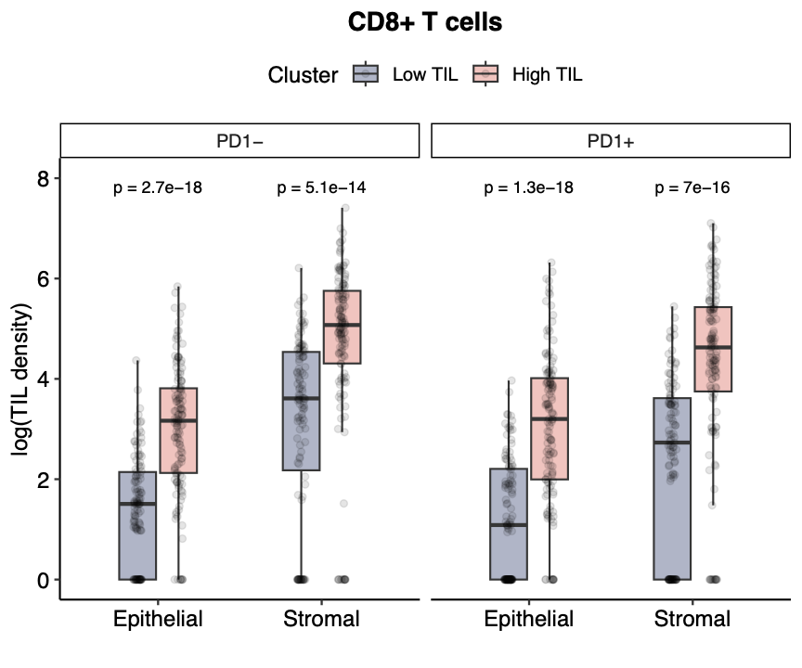

*Figure S2.* The density of PD-1 positive and PD-1 negative CD8+ T cells in epithelial and stromal areas is compared in TIL-rich and TIL-poor cases.

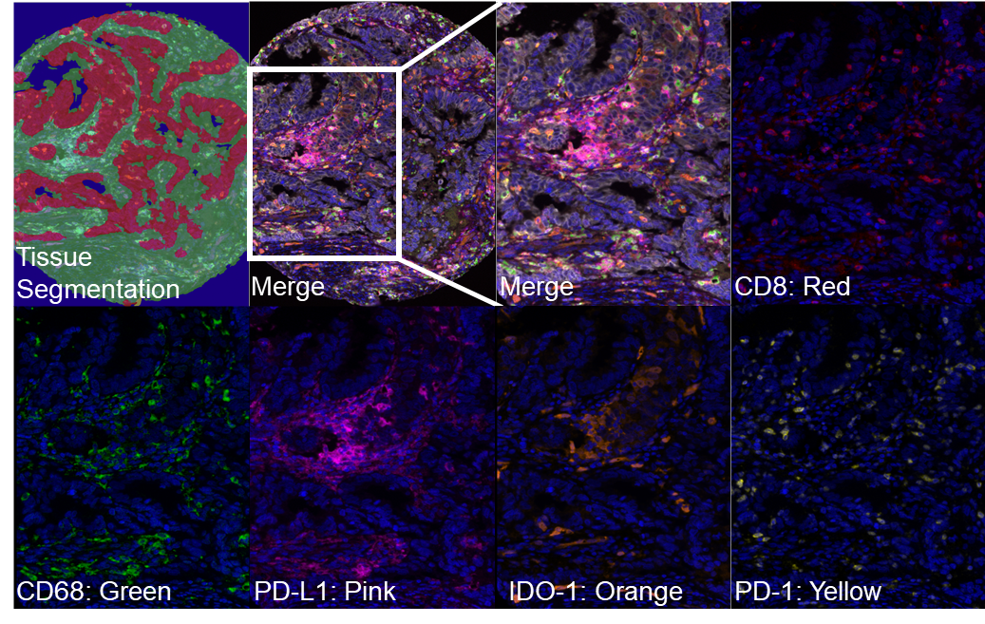

Figure S##: Representative multiplex immunofluorescence for the adaptive resistance panel. Representative segmentation of the tumor (red), stromal (green), and glass/necrosis (blue) are shown in the top left panel. Each image shows a single immune marker as annotated in addition to DAPI staining, or the merged image.

### 3.6 Immune infiltration varies independently of targetable genomic alterations

Finally, we evaluated the relationship between TIL subgroups and therapeutically targetable genomic properties. We leveraged shallow whole genome sequencing data-derived copy number signatures described in endometrial cancer [(35)](https://www.zotero.org/google-docs/?3hkDUM) to identify homologous recombination deficient (HRD) tumors (targetable with PARP inhibition) and HER2-amplified tumors (targetable with anti-HER2 antibodies) in a subset of 126 tumors of our cohort. The HRD signature failed to significantly associate with TIL cluster (**Figure 6a,b**). Moreover, densities of individual TIL types in epithelial and stromal regions failed to t significantly correlate with any mutational signature. Furthermore, TIL cluster failed to correlate with HER2 IHC status (*P* = 0.95) or HER2 amplification by shallow whole-genome sequencing (*P* = 0.11) (**Figure 6c,d**). Thus, the TIL-rich signature is distinct from the HRD and HER2 signatures, possibly expanding the patient cohort amenable to targeted therapies.

|  |
| --- |
| *Figure 6:* (a) Relative proportions of each copy-number mutation signature within each tumor sample (n = 126). (b) Relationship between copy number signatures and TIL cluster. (c-d) Proportion of TIL-rich samples by (c) HER2 IHC and (d) HER2 copy number status. |

## 4 Discussion

Historically considered one of the less immunogenic subtypes of endometrial cancer, p53abn tumors had, until recently, received minimal attention in immunotherapy research. However recent phase III clinical trials of dostarlimab in addition to standard-of-care chemotherapy demonstrated benefit in both MMRd and MMRp cancers [(29)](https://www.zotero.org/google-docs/?pCCqjU), with p53abn cases responding substantially better than NSMP cases [(30)](https://www.zotero.org/google-docs/?8y6Bml). These results motivated us to systemically profile the immune microenvironment in one of the largest cohorts of p53abn endometrial cancers to date. Analysis revealed two immunologically distinct subgroups defined by extensive (TIL-rich) and limited (TIL-poor) infiltration of T cells and B cells. Within our cohort, a broad range of levels of immune infiltration were identified, with over half of cases highly infiltrated by TIL, challenging the belief that p53abn cancers are immune depleted [(51)](https://www.zotero.org/google-docs/?5yAthc). Not only were over half of cases considered TIL-rich, but these cases had increased markers of an active immune response, including higher CTL:Treg ratios, higher percentages of CTL expressing PD-1 (indicating active CTL), and increased PD-L1 expression by tumor cells and macrophages, indicating tumor response to immune attack. In multivariate analysis, we found that TIL-rich tumors were associated with longer overall and disease-specific survival, in contrast to prior findings in smaller cohorts [(13,14)](https://www.zotero.org/google-docs/?vAsU9A). Notably, the TIL-rich group was strongly associated with survival in patients with advanced disease and those who did not subsequently receive chemotherapy. Finally, we found that TIL-rich tumors failed to associate with either homologous recombination deficient (HRD) or HER2-overexpressing tumors. Our findings may help to inform personalized treatment of p53abn endometrial carcinoma by helping to identify patients most likely to respond to immunotherapy, PARP inhibition, HER2-directed therapies, and chemotherapy.

In analyzing the immune composition of p53abn endometrial cancer, we found multiple differences from HGSOC and triple-negative breast cancer (TNBC), which morphologically and genomically resemble p53abn endometrial cancer [(2)](https://www.zotero.org/google-docs/?oWI7zc). In HGSOC and TNBC, we [(33)](https://www.zotero.org/google-docs/?bgIviB) and others [(52)](https://www.zotero.org/google-docs/?EZThl4) identified a stroma-restricted pattern of TIL, which was associated with inferior prognosis compared to tumors with intraepithelial TIL. In the current study, the stroma-restricted TIL subtype was absent in p53abn endometrial carcinomas. Moreover, whereas immune infiltration correlated with HRD in HGSOC [(33,53,54)](https://www.zotero.org/google-docs/?bgJZZL), immune infiltration failed to correlate with HRD or any other mutational processes in p53abn endometrial carcinoma. The differences we observed in immune infiltration patterns between HGSOC and p53abn EC have also been reflected in immunotherapy clinical trial results: MMRp endometrial carcinomas show striking benefit from immunotherapy compared to HGSOC [(29,30,55)](https://www.zotero.org/google-docs/?I5xjL7). Thus, p53abn endometrial carcinomas and HGSOC and TNBC have therapeutically relevant differences in immune microenvironment dynamics and anti-tumor immunity.

Among all p53abn tumors in our cohort, TIL-rich tumors were associated with overall and disease-specific survival in multivariate analysis; however when stratified by stage and subsequent chemotherapy exposure, we found that the most significant associations were among stage III patients and those that did not receive adjuvant chemotherapy. Stage III endometrial carcinoma encompasses tumors with extension beyond the uterus, either into the uterine serosa, adjacent organs or into lymph nodes. Pre-existing anti-tumor immunity may have played a greater role in these patients. Our finding that TIL-rich tumors were associated with improved survival in patients that did not subsequently receive chemotherapy highlights several theoretical and practical considerations when choosing adjuvant therapies. Chemotherapy can have conflicting effects on anti-tumor immune responses: chemotherapy can cause immunogenic tumor cell death [(56–58)](https://www.zotero.org/google-docs/?Xg6YCW) and release neoantigens into an inflammatory milieu to activate anti-tumor immunity; or conversely inhibit the anti-tumor immune response by eliminating intratumoral anti-tumor T cells and preventing proliferation of tumor-specific immune cells, particularly when delivered at or near the maximum tolerable doses [(57,59)](https://www.zotero.org/google-docs/?A87qbS). Given that the association between TIL-rich tumors and survival was most pronounced in patients who did not subsequently receive chemotherapy, we hypothesize that the immunosuppressive effects of chemotherapy trumped the immunogenic effects in our non-immunotherapy treated cohort. Chemotherapy as a monotherapy has strong association with survival in p53abn EC and should remain a mainstay of treatment (**Table 1**) [(6)](https://www.zotero.org/google-docs/?ZHSAoD); however, careful titration and selection of chemotherapy agents to optimize immunogenic cell death may help to enable synergy with immunotherapy [(57)](https://www.zotero.org/google-docs/?NBMVWW). An alternative hypothesis is that TIL-poor tumors may have converted to TIL-rich tumors by the addition of chemotherapy, obviating the differences between TIL-poor and TIL-rich tumors assessed at the time of surgery. Further work including multiplex examination of recurrent disease is required to determine the effects of chemotherapy on anti-tumor immunity in p53abn endometrial carcinoma.

The presence of a TIL-rich group of p53abn endometrial cancers associated with increased survival could help justify improved targeting of immunotherapies beyond molecular subtype-based strategies [(10,60)](https://www.zotero.org/google-docs/?nmpL2m). While TIL-rich tumors are more frequent in POLE and MMRd [(13,14)](https://www.zotero.org/google-docs/?YJp2nb) than other molecular subtypes, the variance within molecular subtype is greater than the variance between subtypes. Our data suggest immune profiling may help identify p53abn EC patients with intrinsic anti-tumor immune responses that potentially may be augmented by immunotherapy. Importantly, and in contrast to several studies that identified prognostic value of individual immune cell subtypes in various tumor types [(25,61,62)](https://www.zotero.org/google-docs/?947efo), we found no association with survival and any single immune cell type (sup fig) or with PD-L1 expression, necessitating the multiplex approach to immune profiling. Histotype also fails to identify TIL-rich tumors, with carcinosarcoma being the only histotype significantly associated with TIL. Whether carcinosarcomas will show poor response to immune checkpoint inhibition has yet to be determined, but our study indicates that TIL-cluster, not molecular subtype or histotype, may be more informative for stratifying patients with p53abn endometrial cancer for immunotherapy.

Our data examined for the first time the relationship between immune response and mutational processes in p53abn endometrial cancer. Despite genomic similarities between HGSOC and p53abn endometrial cancer [(2,33)](https://www.zotero.org/google-docs/?HUJFJx), TIL-rich tumors were not correlated with mutational signatures, including HRD, in p53abn endometrial cancer. In contrast to HGSOC, p53abn endometrial cancer may elicit TIL responses through mechanisms independent of HRD. Other mutational processes generating widespread genomic instability in endometrial cancer [(35)](https://www.zotero.org/google-docs/?V0jiNV) may elicit TIL responses through common cGAS-STING pathway activation [(63,64)](https://www.zotero.org/google-docs/?DnyJNV). Additionally, we found that TIL-groups failed to correlate with HER2 status by immunohistochemistry or whole-genome sequencing. Thus, immunotherapies, anti-HER2 therapies, and PARP inhibitors targeting HRD tumors may represent orthogonal approaches effective in different groups of p53abn endometrial cancers, with some tumors susceptible to multiple agents.

As the use of immunotherapies extends to MMRp endometrial cancers, the immune microenvironment must be considered in addition to molecular subtype as a relevant factor. Our findings highlight properties of the immune microenvironment that may portend susceptibility to immune checkpoint susceptibility in p53abn endometrial cancers and demonstrate the potential for rational personalized therapy for this deadly disease.

**Acknowledgments**

The authors would like to acknowledge the expert opinion and guiding mentorship of Dr. Naveena Singh. Her enthusiasm for gynecological pathology and glowing personality will be sorely missed. Our hearts go out to her family and loved ones.

**References**

[1. Siegel RL, Giaquinto AN, Ahmedin |, Dvm J, Siegel RL. Cancer statistics, 2024. CA Cancer J Clin. 2024 Jan 1;74(1):12–49.](https://www.zotero.org/google-docs/?2uYwUh)

[2. Getz G, Gabriel SB, Cibulskis K, Lander E, Sivachenko A, Sougnez C, et al. Integrated genomic characterization of endometrial carcinoma. Nature. 2013;497(7447):67–73.](https://www.zotero.org/google-docs/?2uYwUh)

[3. Talhouk A, McConechy MK, Leung S, Li-Chang HH, Kwon JS, Melnyk N, et al. A clinically applicable molecular-based classification for endometrial cancers. Br J Cancer. 2015 Jul 14;113(2):299–310.](https://www.zotero.org/google-docs/?2uYwUh)

[4. Talhouk A, McConechy MK, Leung S, Yang W, Lum A, Senz J, et al. Confirmation of ProMisE: A simple, genomics-based clinical classifier for endometrial cancer. Cancer. 2017 Mar 1;123(5):802–13.](https://www.zotero.org/google-docs/?2uYwUh)

[5. Kommoss S, McConechy MK, Kommoss F, Leung S, Bunz A, Magrill J, et al. Final validation of the ProMisE molecular classifier for endometrial carcinoma in a large population-based case series. 2018 [cited 2024 Mar 9]; Available from: http://nationalacademies.](https://www.zotero.org/google-docs/?2uYwUh)

[6. Lé On-Castillo A, De Boer SM, Powell ME, Mileshkin LR, Mackay HJ, Leary A, et al. Molecular Classification of the PORTEC-3 Trial for High-Risk Endometrial Cancer: Impact on Prognosis and Benefit From Adjuvant Therapy. J Clin Oncol. 2020;38:3388–97.](https://www.zotero.org/google-docs/?2uYwUh)

[7. Jamieson A, Thompson EF, Huvila J, Gilks CB, McAlpine JN. p53abn Endometrial Cancer: understanding the most aggressive endometrial cancers in the era of molecular classification. Int J Gynecol Cancer. 2021 Jun 1;31(6):907–13.](https://www.zotero.org/google-docs/?2uYwUh)

[8. Siegenthaler F, Lindemann K, Epstein E, Rau TT, Nastic D, Ghaderi M, et al. Time to first recurrence, pattern of recurrence, and survival after recurrence in endometrial cancer according to the molecular classification. Gynecol Oncol. 2022 May 1;165(2):230–8.](https://www.zotero.org/google-docs/?2uYwUh)

[9. Momeni-Boroujeni A, Dahoud W, Vanderbilt CM, Chiang S, Murali R, Rios-Doria EV, et al. Clinicopathologic and genomic analysis of TP53-mutated endometrial carcinomas. Clin Cancer Res. 2021 May 1;27(9):2613–23.](https://www.zotero.org/google-docs/?2uYwUh)

[10. Ott PA, Bang YJ, Berton-Rigaud D, Elez E, Pishvaian MJ, Rugo HS, et al. Safety and Antitumor Activity of Pembrolizumab in Advanced Programmed Death Ligand 1–Positive Endometrial Cancer: Results From the KEYNOTE-028 Study. https://doi.org/101200/JCO2017725952. 2017 May 10;35(22):2535–41.](https://www.zotero.org/google-docs/?2uYwUh)

[11. Asaka S, Yen TT, Wang TL, Shih IM, Gaillard S. T cell-inflamed phenotype and increased Foxp3 expression in infiltrating T-cells of mismatch-repair deficient endometrial cancers. Mod Pathol Off J U S Can Acad Pathol Inc. 2019 Apr;32(4):576–84.](https://www.zotero.org/google-docs/?2uYwUh)

[12. López-Janeiro Á, Villalba-Esparza M, Brizzi ME, Jiménez-Sánchez D, Ruz-Caracuel I, Kadioglu E, et al. The association between the tumor immune microenvironments and clinical outcome in low-grade, early-stage endometrial cancer patients. J Pathol. 2022 Dec;258(4):426–36.](https://www.zotero.org/google-docs/?2uYwUh)

[13. Eggink FA, Van Gool IC, Leary A, Pollock PM, Crosbie EJ, Mileshkin L, et al. Immunological profiling of molecularly classified high-risk endometrial cancers identifies POLE-mutant and microsatellite unstable carcinomas as candidates for checkpoint inhibition. Oncoimmunology. 2017;6(2):e1264565.](https://www.zotero.org/google-docs/?2uYwUh)

[14. Talhouk A, Derocher H, Schmidt P, Leung S, Milne K, Blake Gilks C, et al. Molecular Subtype Not Immune Response Drives Outcomes in Endometrial Carcinoma. Clin Cancer Res Off J Am Assoc Cancer Res. 2019 Apr 15;25(8):2537–48.](https://www.zotero.org/google-docs/?2uYwUh)

[15. Mantovani A, Allavena P, Marchesi F, Garlanda C. Macrophages as tools and targets in cancer therapy. Nat Rev Drug Discov. 2022 Nov;21(11):799–820.](https://www.zotero.org/google-docs/?2uYwUh)

[16. Chen Y, Song Y, Du W, Gong L, Chang H, Zou Z. Tumor-associated macrophages: an accomplice in solid tumor progression. J Biomed Sci. 2019 Oct 20;26(1):78.](https://www.zotero.org/google-docs/?2uYwUh)

[17. Sakaguchi S, Mikami N, Wing JB, Tanaka A, Ichiyama K, Ohkura N. Regulatory T Cells and Human Disease. Annu Rev Immunol. 2020 Apr 26;38:541–66.](https://www.zotero.org/google-docs/?2uYwUh)

[18. Wardell CM, MacDonald KN, Levings MK, Cook L. Cross talk between human regulatory T cells and antigen-presenting cells: Lessons for clinical applications. Eur J Immunol. 2021 Jan;51(1):27–38.](https://www.zotero.org/google-docs/?2uYwUh)

[19. Laumont CM, Banville AC, Gilardi M, Hollern DP, Nelson BH. Tumour-infiltrating B cells: immunological mechanisms, clinical impact and therapeutic opportunities. Nat Rev Cancer. 2022 Jul;22(7):414–30.](https://www.zotero.org/google-docs/?2uYwUh)

[20. Laumont CM, Nelson BH. B cells in the tumor microenvironment: Multi-faceted organizers, regulators, and effectors of anti-tumor immunity. Cancer Cell. 2023 Mar 13;41(3):466–89.](https://www.zotero.org/google-docs/?2uYwUh)

[21. Feng X, Tang R, Zhang R, Wang H, Ji Z, Shao Y, et al. A comprehensive analysis of IDO1 expression with tumour-infiltrating immune cells and mutation burden in gynaecologic and breast cancers. J Cell Mol Med. 2020 May;24(9):5238–48.](https://www.zotero.org/google-docs/?2uYwUh)

[22. Topalian SL, Taube JM, Anders RA, Pardoll DM. Mechanism-driven biomarkers to guide immune checkpoint blockade in cancer therapy. Nat Rev Cancer. 2016 May;16(5):275–87.](https://www.zotero.org/google-docs/?2uYwUh)

[23. Santoro A, Angelico G, Inzani F, Arciuolo D, d’Amati A, Addante F, et al. The emerging and challenging role of PD-L1 in patients with gynecological cancers: An updating review with clinico-pathological considerations. Gynecol Oncol. 2024 May;184:57–66.](https://www.zotero.org/google-docs/?2uYwUh)

[24. Holder AM, Dedeilia A, Sierra-Davidson K, Cohen S, Liu D, Parikh A, et al. Defining clinically useful biomarkers of immune checkpoint inhibitors in solid tumours. Nat Rev Cancer. 2024 Jul;24(7):498–512.](https://www.zotero.org/google-docs/?2uYwUh)

[25. Martin SD, Bhuiyan I, Soleimani M, Wang G. Biomarkers for Immune Checkpoint Inhibitors in Renal Cell Carcinoma. J Clin Med. 2023 Jul 28;12(15):4987.](https://www.zotero.org/google-docs/?2uYwUh)

[26. Chan TA, Yarchoan M, Jaffee E, Swanton C, Quezada SA, Stenzinger A, et al. Development of tumor mutation burden as an immunotherapy biomarker: utility for the oncology clinic. Ann Oncol. 2019 Jan 1;30(1):44–56.](https://www.zotero.org/google-docs/?2uYwUh)

[27. Konstantinopoulos PA, Luo W, Liu JF, Gulhan DC, Krasner C, Ishizuka JJ, et al. Phase II study of avelumab in patients with mismatch repair deficient and mismatch repair proficient recurrent/persistent endometrial cancer. J Clin Oncol. 2019;37(30):2786–94.](https://www.zotero.org/google-docs/?2uYwUh)

[28. Antill Y, Kok PS, Robledo K, Yip S, Cummins M, Smith D, et al. Clinical activity of durvalumab for patients with advanced mismatch repair-deficient and repair-proficient endometrial cancer. A nonrandomized phase 2 clinical trial. J Immunother Cancer [Internet]. 2021 Jun 8 [cited 2024 Mar 23];9(6). Available from: https://pubmed.ncbi.nlm.nih.gov/34103352/](https://www.zotero.org/google-docs/?2uYwUh)

[29. Mirza MR, Chase DM, Slomovitz BM, dePont Christensen R, Novák Z, Black D, et al. Dostarlimab for Primary Advanced or Recurrent Endometrial Cancer. N Engl J Med. 2023 Jun 8;388(23):2145–58.](https://www.zotero.org/google-docs/?2uYwUh)

[30. Mirza MR, Sharma S, Herrstedt J, Shahin MS, Cibula D, Fleming E, et al. 740MO Dostarlimab + chemotherapy for the treatment of primary advanced or recurrent endometrial cancer (pA/rEC): Analysis of progression free survival (PFS) and overall survival (OS) outcomes by molecular classification in the ENGOT-EN6-NSGO/GOG-3031/RUBY trial. Ann Oncol. 2023 Oct 1;34:S507.](https://www.zotero.org/google-docs/?2uYwUh)

[31. Bosse T, Creutzberg CL, Crosbie EJ, Han K, Horeweg N, Leary A, et al. Refining adjuvant treatment in endometrial cancer based on molecular features: the RAINBO clinical trial program. Int J Gynecol Cancer. 2023 Jan 1;33(1):109–17.](https://www.zotero.org/google-docs/?2uYwUh)

[32. Friedlander M, Lee YC, Tew WP. Managing Adverse Effects Associated With Poly (ADP-ribose) Polymerase Inhibitors in Ovarian Cancer: A Synthesis of Clinical Trial and Real-World Data. Am Soc Clin Oncol Educ Book Am Soc Clin Oncol Annu Meet [Internet]. 2023 Jun [cited 2024 Apr 1];43(43). Available from: https://pubmed.ncbi.nlm.nih.gov/37285556/](https://www.zotero.org/google-docs/?2uYwUh)

[33. Zhang AW, McPherson A, Milne K, Kroeger DR, Hamilton PT, Miranda A, et al. Interfaces of Malignant and Immunologic Clonal Dynamics in Ovarian Cancer. Cell. 2018 Jun 14;173(7):1755-1769.e22.](https://www.zotero.org/google-docs/?2uYwUh)

[34. Wallbillich JJ, Morris RT, Ali-Fehmi R. Comparing mutation frequencies for homologous recombination genes in uterine serous and high-grade serous ovarian carcinomas: A case for homologous recombination deficiency testing in uterine serous carcinoma ☆. 2020 [cited 2024 Mar 9]; Available from: https://doi.org/10.1016/j.ygyno.2020.08.012](https://www.zotero.org/google-docs/?2uYwUh)

[35. Jamieson A, Sobral de Barros J, Cochrane DR, Douglas JM, Shankar S, Lynch BJ, et al. Targeted and Shallow Whole-Genome Sequencing Identifies Therapeutic Opportunities in p53abn Endometrial Cancers. Clin Cancer Res Off J Am Assoc Cancer Res. 2024 Jun 3;30(11):2461–74.](https://www.zotero.org/google-docs/?2uYwUh)

[36. Lumish M, Chui MH, Zhou Q, Iasonos A, Sarasohn D, Cohen S, et al. A phase 2 trial of zanidatamab in HER2-overexpressed advanced endometrial carcinoma and carcinosarcoma (ZW25-IST-2). Gynecol Oncol. 2024 Mar;182:75–81.](https://www.zotero.org/google-docs/?2uYwUh)

[37. Fader AN, Roque DM, Siegel E, Buza N, Hui P, Abdelghany O, et al. Randomized Phase II Trial of Carboplatin-Paclitaxel Compared with Carboplatin-Paclitaxel-Trastuzumab in Advanced (Stage III-IV) or Recurrent Uterine Serous Carcinomas that Overexpress Her2/Neu (NCT01367002): Updated Overall Survival Analysis. Clin Cancer Res Off J Am Assoc Cancer Res. 2020 Aug 1;26(15):3928–35.](https://www.zotero.org/google-docs/?2uYwUh)

[38. Karpel HC, Slomovitz B, Coleman RL, Pothuri B. Treatment options for molecular subtypes of endometrial cancer in 2023. Curr Opin Obstet Gynecol. 2023 Jun 1;35(3):270–8.](https://www.zotero.org/google-docs/?2uYwUh)

[39. Konstantinopoulos PA, Gockley AA, Xiong N, Krasner C, Horowitz N, Campos S, et al. Evaluation of Treatment With Talazoparib and Avelumab in Patients With Recurrent Mismatch Repair Proficient Endometrial Cancer. JAMA Oncol. 2022 Sep 1;8(9):1317–22.](https://www.zotero.org/google-docs/?2uYwUh)

[40. Kapourani CA, Sanguinetti G. Higher order methylation features for clustering and prediction in epigenomic studies. Bioinforma Oxf Engl. 2016 Sep 1;32(17):i405–12.](https://www.zotero.org/google-docs/?2uYwUh)

[41. Zhang AW, O’Flanagan C, Chavez EA, Lim JLP, Ceglia N, McPherson A, et al. Probabilistic cell-type assignment of single-cell RNA-seq for tumor microenvironment profiling. Nat Methods. 2019 Oct;16(10):1007–15.](https://www.zotero.org/google-docs/?2uYwUh)

[42. Abril-Pla O, Andreani V, Carroll C, Dong L, Fonnesbeck CJ, Kochurov M, et al. PyMC: a modern, and comprehensive probabilistic programming framework in Python. PeerJ Comput Sci [Internet]. 2023 [cited 2024 Mar 30];9. Available from: /pmc/articles/PMC10495961/](https://www.zotero.org/google-docs/?2uYwUh)

[43. Macintyre G, Goranova TE, De Silva D, Ennis D, Piskorz AM, Eldridge M, et al. Copy number signatures and mutational processes in ovarian carcinoma. Nat Genet. 2018 Sep 13;50(9):1262–70.](https://www.zotero.org/google-docs/?2uYwUh)

[44. Sauer CM, Eldridge MD, Vias M, Hall JA, Boyle S, Macintyre G, et al. Absolute copy number fitting from shallow whole genome sequencing data [Internet]. bioRxiv; 2021 [cited 2024 Jul 14]. p. 2021.07.19.452658. Available from: https://www.biorxiv.org/content/10.1101/2021.07.19.452658v1](https://www.zotero.org/google-docs/?2uYwUh)

[45. Grambsch PM, Therneau TM. Proportional Hazards Tests and Diagnostics Based on Weighted Residuals. Biometrika. 1994 Aug;81(3):515.](https://www.zotero.org/google-docs/?2uYwUh)

[46. Creasman W. Revised FIGO staging for carcinoma of the endometrium. Int J Gynecol Obstet. 2009 May 1;105(2):109–109.](https://www.zotero.org/google-docs/?2uYwUh)

[47. Zhang C, Hu W, Jia N, Li Q, Hua K, Tao X, et al. Uterine carcinosarcoma and high-risk endometrial carcinomas: a clinicopathological comparison. Int J Gynecol Cancer Off J Int Gynecol Cancer Soc. 2015 May 7;25(4):629–36.](https://www.zotero.org/google-docs/?2uYwUh)

[48. Bernardini MQ, Gien LT, Lau S, Altman AD, Gilks B, Ferguson SE, et al. Treatment related outcomes in high-risk endometrial carcinoma: Canadian high risk endometrial cancer consortium (CHREC). Gynecol Oncol. 2016 Apr 1;141(1):148–54.](https://www.zotero.org/google-docs/?2uYwUh)

[49. Raffone A, Travaglino A, Raimondo D, Maletta M, De Vivo V, Visiello U, et al. Uterine carcinosarcoma vs endometrial serous and clear cell carcinoma: A systematic review and meta‐analysis of survival. Int J Gynaecol Obstet. 2022 Sep 1;158(3):520.](https://www.zotero.org/google-docs/?2uYwUh)

[50. Di Tucci C, Capone C, Galati G, Iacobelli V, Schiavi MC, Di Donato V, et al. Immunotherapy in endometrial cancer: new scenarios on the horizon. J Gynecol Oncol [Internet]. 2019 May 1 [cited 2024 Mar 30];30(3). Available from: /pmc/articles/PMC6424849/](https://www.zotero.org/google-docs/?2uYwUh)

[51. Mendiola M, Pellinen T, Ramon-Patino JL, Berjon A, Bruck O, Heredia-Soto V, et al. Prognostic implications of tumor-infiltrating T cells in early-stage endometrial cancer. Mod Pathol. 2022 Feb 1;35(2):256–65.](https://www.zotero.org/google-docs/?2uYwUh)

[52. Gruosso T, Gigoux M, Manem VSK, Bertos N, Zuo D, Perlitch I, et al. Spatially distinct tumor immune microenvironments stratify triple-negative breast cancers. J Clin Invest. 129(4):1785–800.](https://www.zotero.org/google-docs/?2uYwUh)

[53. Nelson BH, Greenberg PD, Schreiber H. New insights into tumor immunity revealed by the unique genetic and genomic aspects of ovarian cancer. Curr Opin Immunol. 2015;33:93–100.](https://www.zotero.org/google-docs/?2uYwUh)

[54. Vázquez-García I, Uhlitz F, Ceglia N, Lim JLP, Wu M, Mohibullah N, et al. Ovarian cancer mutational processes drive site-specific immune evasion. Nature. 2022 Dec;612(7941):778–86.](https://www.zotero.org/google-docs/?2uYwUh)

[55. Matulonis UA, Shapira-Frommer R, Santin AD, Lisyanskaya AS, Pignata S, Vergote I, et al. Antitumor activity and safety of pembrolizumab in patients with advanced recurrent ovarian cancer: results from the phase II KEYNOTE-100 study. Ann Oncol Off J Eur Soc Med Oncol. 2019 Jul 1;30(7):1080–7.](https://www.zotero.org/google-docs/?2uYwUh)

[56. Pfirschke C, Engblom C, Rickelt S, Cortez-Retamozo V, Garris C, Pucci F, et al. Immunogenic Chemotherapy Sensitizes Tumors to Checkpoint Blockade Therapy. Immunity. 2016 Feb 16;44(2):343–54.](https://www.zotero.org/google-docs/?2uYwUh)

[57. Galluzzi L, Humeau J, Buqué A, Zitvogel L, Kroemer G. Immunostimulation with chemotherapy in the era of immune checkpoint inhibitors. Nat Rev Clin Oncol. 2020 Dec;17(12):725–41.](https://www.zotero.org/google-docs/?2uYwUh)

[58. Casares N, Pequignot MO, Tesniere A, Ghiringhelli F, Roux S, Chaput N, et al. Caspase-dependent immunogenicity of doxorubicin-induced tumor cell death. J Exp Med. 2005 Dec 19;202(12):1691–701.](https://www.zotero.org/google-docs/?2uYwUh)

[59. Yu WD, Sun G, Li J, Xu J, Wang X. Mechanisms and therapeutic potentials of cancer immunotherapy in combination with radiotherapy and/or chemotherapy. Cancer Lett. 2019 Jun 28;452:66–70.](https://www.zotero.org/google-docs/?2uYwUh)

[60. Yamashita H, Nakayama K, Ishikawa M, Nakamura K, Ishibashi T, Sanuki K, et al. Microsatellite instability is a biomarker for immune checkpoint inhibitors in endometrial cancer. Oncotarget. 2017;9(5):5652–64.](https://www.zotero.org/google-docs/?2uYwUh)

[61. Bruni D, Angell HK, Galon J. The immune contexture and Immunoscore in cancer prognosis and therapeutic efficacy. Nat Rev Cancer. 2020 Nov;20(11):662–80.](https://www.zotero.org/google-docs/?2uYwUh)

[62. Wouters MCA, Nelson BH. Prognostic Significance of Tumor-Infiltrating B Cells and Plasma Cells in Human Cancer. Clin Cancer Res Off J Am Assoc Cancer Res. 2018 Dec 15;24(24):6125–35.](https://www.zotero.org/google-docs/?2uYwUh)

[63. Woo SR, Fuertes MB, Corrales L, Spranger S, Furdyna MJ, Leung MYK, et al. STING-dependent cytosolic DNA sensing mediates innate immune recognition of immunogenic tumors. Immunity. 2014 Nov 20;41(5):830–42.](https://www.zotero.org/google-docs/?2uYwUh)

[64. Deng L, Liang H, Xu M, Yang X, Burnette B, Arina A, et al. STING-dependent cytosolic DNA sensing promotes radiation-induced type I interferon-dependent antitumor immunity in immunogenic tumors. Immunity. 2014 Nov 20;41(5):843–52.](https://www.zotero.org/google-docs/?2uYwUh)